LECT NO.3 **Course Outcome to be covered: CO1:** Merits of digital systems, various number systems and their applications.

**Lecture Outcome:** Students will know about number system , their types , conversions and applications.

• **Introduction**

A number system is a mathematical for representing numbers of a given set, using digits or other symbols in a consistent manner. Number systems are sometimes also called numeral systems. One of the most ancient and common system of numbers was the Indian number system is the place-value notation developed by Arya-Bhata in the 5th Century. In the 6th century Brahm-Gupta introduced the symbol for zero and this number system then spread throughout the world to become the decimal number system that is presently universally used in human writing. Ideally, a number system will:

* Represent a useful set of numbers for eg. Integers
* Give every number represented a unique representation
* Reflect the algebraic and arithmetic structure of the numbers.

For example, the decimal representation of whole numbers gives every nonzero whole number a unique representation as a finite sequence of digits beginning with a non-zero digit. For eg. the number 56484 has a value.

Number systems is a technique that is also used in representing numbers in computer system architecture. The digital computer represents all kinds of data and information in binary numbers. This implies every value/number that you are saving or feeding into/fetching from the computer system memory has a defined number system. The value/data feed in/fetch from can includes but not limited to: audio, graphics, video, text file, numbers etc. The total number of digits used in a number system is called its base or radix. The base is written after the number as subscript; for instance 10001102 (1000110 base 2), 5610 (56 to base of 10), 718 (71 base 8) etc.

**Types of Number Systems:**

Fig [2.1]: Types of Number System

There are two types of number systems:

* Weighted number system
* Non weighted number system

**Weighted Number System**

Each Digit has a weight or value. The weighted codes are those that obey the position weighting principle, which states that the position of each number represent a specific weight. Example: 8421/BCD code, 1001 the weights of 1, 1, 0, 1 (from left to right) are 8, 4, 2 and 1 respectively.

**Non Weighted Number System**

The non-weighted codes are not positionally weighted. In other words codes that are not assigned with any weight to each digit position. Example is gray code, excess3

**Classification of Weighted Number Systems:**

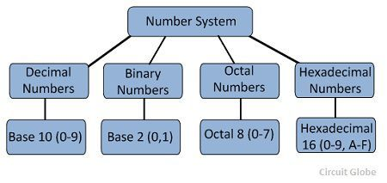

Fig[2.2]:Types of weighted number system

* Binary
* Decimal
* Octal
* Hexadecimal

**Binary Number System:**Binary number system has only two digits that are **0 and 1**. Every number (value) represents with 0 and 1 in this number system. The base of binary number system is 2, because it has only two digits. eg. (1101)2

**Decimal Number System:** Decimal number system has only ten (10) digits from 0 to 9. Every number (value) is represented with 0,1,2,3,4,5,6,7,8 and 9 in this number system. The base of decimal number system is 10, because it has only 10 digits. Example (234.12)10 , (954.01)10

**Octal Number System:** Octal number system has only eight (8) digits from **0 to 7**. Every number (value) represents with 0,1,2,3,4,5,6 and 7 in this number system. The base of octal number system is 8, because it has only 8 digits. Example (234.67)8

**Hexadecimal Number System:** A Hexadecimal number system has sixteen (16) alphanumeric values from **0 to 9** and **A to F**. Every number (value) represents with 0,1,2,3,4,5,6,7,8,9,A,B,C,D,E and F in this number system. The base of hexadecimal number system is 16, because it has 16 alphanumeric values. Here A is 10, B is 11, C is 12, D is 14, E is 15 and F is 16.Example (AB92.32)16

Table [2.1]: Number System Comparison

**Conversion of Number System:**

**Decimal to Other(All Number System)**

**RULES:** To convert Number system from **Decimal Number System** to **Any Other Base** is quite easy; you have to follow just two steps:

* Divide the Number (Decimal Number) bythe base of target base system (in which you want to convert the number: Binary(2), octal (8) and Hexadecimal (16)).
* Write the remainder from step 1 as aLeast Signification Bit (LSB) to Step last as a Most Significant Bit (MSB).
* In case of decimal point number, Thenumber before decimal point is to be divided by base of desired number systemand the number after decimal point is tobe multiplied by base of the desired number system.

**Decimal to Binary:**

**Example**: Convert (20)10 into binary

Sol.

**Example**: Convert (100)10into octal.

Sol.

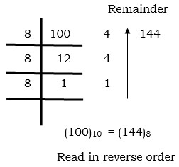

Ans: (144)8

**Decimal to hexadecimal:**

**Example** : Convert (10767)10into Hexadecimal.

Sol.

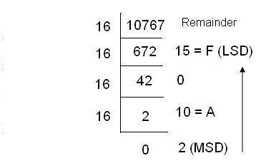

**Example 3**: Convert (25. 35)1010 into binary.

Sol.

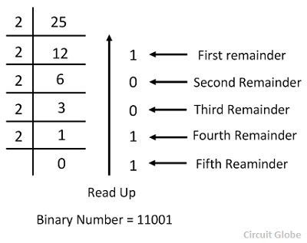

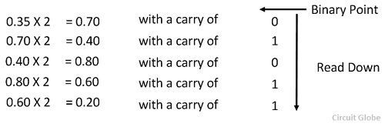

Ans. (11001.01011)2

**Points to remember:**

* When converting from decimal to other number system while dividing answer is to be written from bottom to top.
* In case of fractional decimal numbers,answer is to be written from top to bottom
* In case of hexadecimal numbers A means 10, B means 11, C means 12,D means 13,E means 14,F means 15.

**Applications:** These are basic applications **:**

* Computer language and programming
* Digital encoding
* Digital binary clock,

Frequently used in everyday life in:

* Accounting
* Calendar systems
* Financial systems or daily routine counting.

• **Books:**

[**https://www.amazon.in/Electronics-Analog-Digital-Nagrath-I-J/dp/8120348028**](https://www.amazon.in/Electronics-Analog-Digital-Nagrath-I-J/dp/8120348028)

Electronics: Analog and Digital by Nagrath I.J-Amazon link

**Lecture Notes:**

[**https://www.tutorialspoint.com/computer_logical_organization/number_system_conversion.htm**](https://www.tutorialspoint.com/computer_logical_organization/number_system_conversion.htm)

[**https://www.tutorialspoint.com/digital_electronics/index.asp**](https://www.tutorialspoint.com/digital_electronics/index.asp)

**Video Link:**

[**https://onlinecourses.nptel.ac.in/noc19_ee51/unit?unit=14&lesson=15**](https://onlinecourses.nptel.ac.in/noc19_ee51/unit?unit=14&lesson=15)

**References:**

[**https://www.google.com/search?q=number+system+in+digital+electronics&source=lnms&tbm=isch&sa=X&ved=0ahUKEwjOsbqmnvPiAhXPZCsKHXrSBJYQ_AUIESgC&biw=1366&bih=657#imgrc=DBR-RpBVZAmHDM:**](https://www.google.com/search?q=number+system+in+digital+electronics&source=lnms&tbm=isch&sa=X&ved=0ahUKEwjOsbqmnvPiAhXPZCsKHXrSBJYQ_AUIESgC&biw=1366&bih=657#imgrc=DBR-RpBVZAmHDM:)